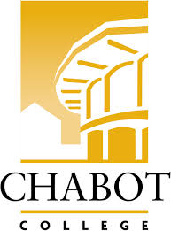**Career Education (CE Committee)**

Chabot College – Zoom

Monday, February 24, 2025

12:00-1:00

**AGENDA**

1. Welcome & Land acknowledgement – Terra
2. Review and approve minutes of last meeting
3. Announcements
   1. Career Open House update - Robin
   2. CE Events (on campus) - Terra / Kristina
      1. Chabot College Career Fair - 2/27
      2. Women in Manufacturing Skills Trade- 2/28
      3. ROP Careers in Healthcare Day – 3/7
      4. Professionals in the Legal Field Workshop – 3/14
      5. CE Open House – 3/22
      6. SOAR Day – 4/19
      7. ECD Job Fair – 4/29
      8. ROP Digital Media Day – 5/2
      9. Ambulance Meet & Greet Day – 5/23
4. Job Developer – John
5. CE Website - Robin
6. Good of the Order - Kristina
7. Next Meeting 3/10/2025
8. Adjournment

**Mission Statement**

*Chabot College is a dynamic, student-centered community college that serves the educational, career, job skill, and personal development needs of our community. We provide culturally responsive, revitalizing, and sustaining learning and support services driven by a goal of equity. Building upon students’ strengths and voices, we empower students to achieve their goals and lead us towards an equitable and sustainable world.*